Procurement Cloud Services. How to do Solicitations in Supplier Portal.

Authors: Monika Lasota, Fang Wang
File Name: Fermilab - Solicitation Supplier Portal instructions
Version: 1.0
Release Date: June 10th 2019

Table of contents
1. How to acknowledge participation in a solicitation 2
2. How to view a solicitation 4
3. How to respond to a solicitation 7
4. How to send a message to your solicitation buyer 10
5. How to respond to a message from a solicitation buyer 12
6. How to revise a solicitation response 15
7. How to respond to a solicitation amendment 17
8. How to withdraw from a solicitation 20

How to acknowledge participation in a solicitation

This section provides instructions on how to acknowledge your participation in a solicitation in the Supplier Portal.
  - On the Supplier Portal login screen, enter your username and password. Then click the Sign In button.
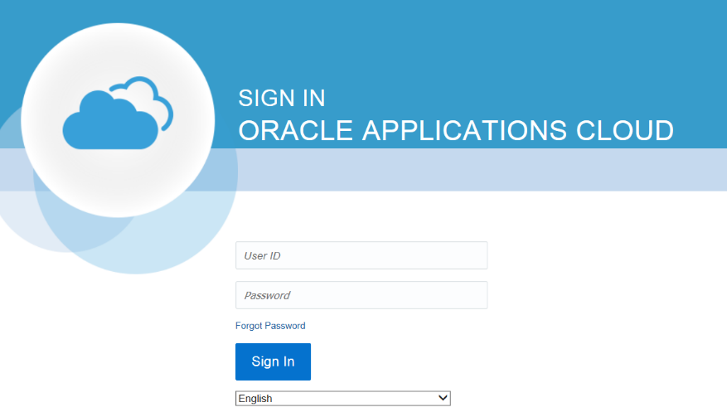

  - Click the bell-shaped Notification icon in the top-right corner.
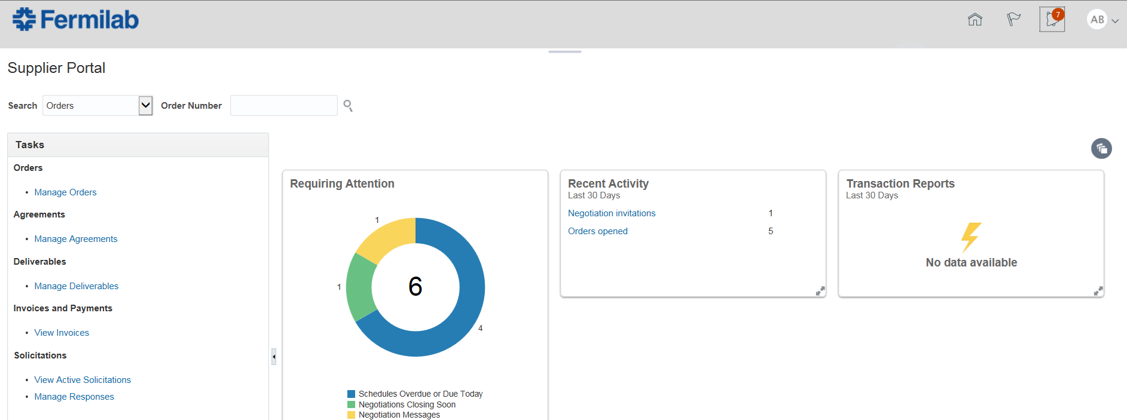

  - In the notification list, look for the solicitation invitation. Click the link to open it.

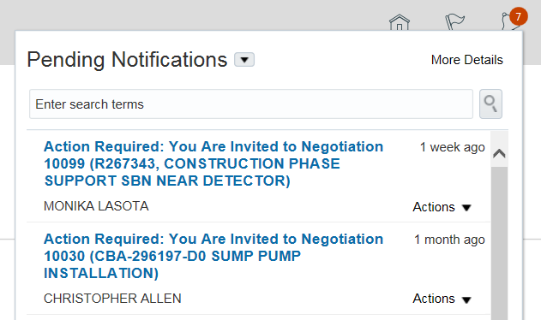

Note: Alternatively, you can view the solicitation via your worklist. To access your worklist, click the Home icon and then click the Worklist icon. You will see the same item in your worklist.
  - Click the link Acknowledge Participation: xxxxx.
  - From the Actions menu, click Respond > Acknowledge Participation.
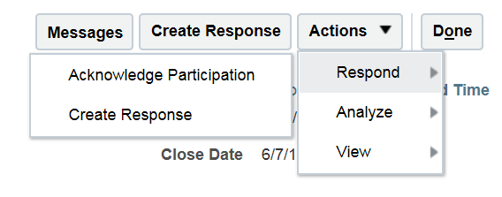
  - Select if you will participate in the solicitation by selecting the Yes or No option. If you want to add a note to the buyer, type it in the Note to Buyer box. Then click OK.

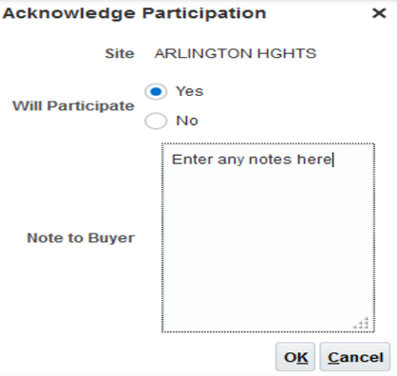
  - Click the Done button. The solicitation status page will be displayed.
  - Click the Done button.

How to view a solicitation

This section provides instructions on how to view a solicitation in the Supplier Portal. Note: You will also receive email notification when you are invited to solicitation.

  - On the Supplier Portal login screen, enter your username and password. Then click the Sign In button.

  - Click the bell-shaped Notification icon in the top-right corner.

  - In the notification list, look for the solicitation invitation. Click the link to open it.

Note: Alternatively, you can view the solicitation via your worklist. To access your worklist, click the Home icon and then click the Worklist icon. You will see the same item in your worklist.
  - Look through the page to get the general information for the solicitation. A sample solicitation is shown below.
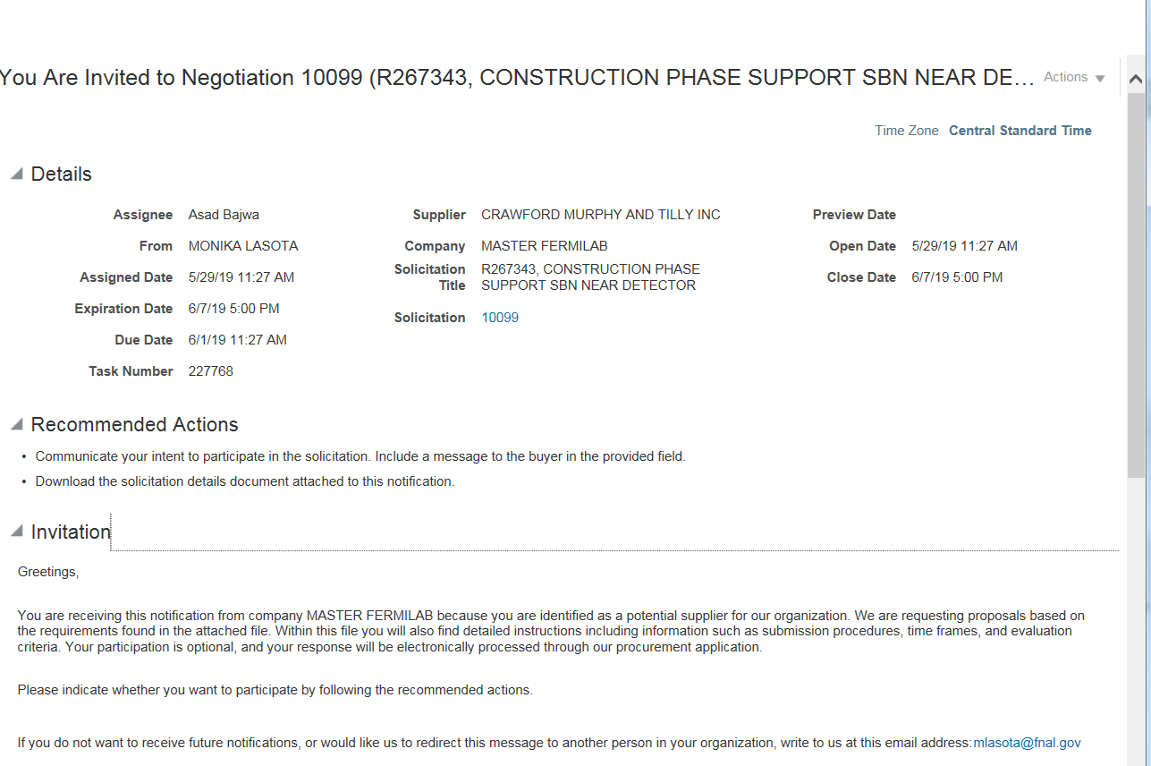
  - To view more details about this solicitation, scroll down the page and click the PDF link at the bottom of the page. You can also download the PDF file to your computer. This PDF document will provide you detailed information about submission procedures, time frames, and evaluation criteria.
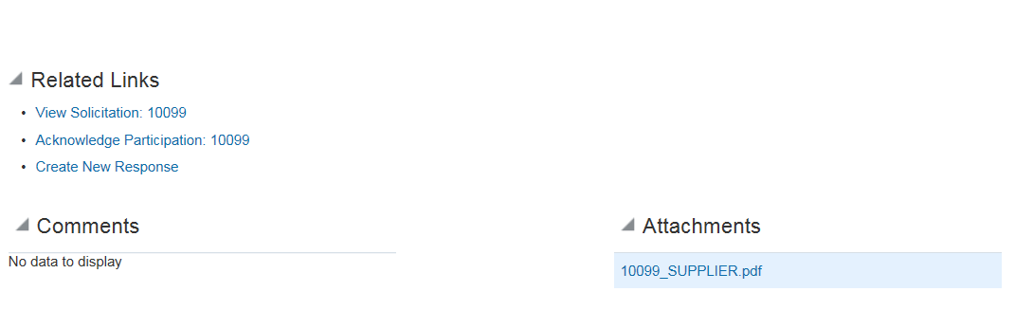

How to respond to a solicitation

This section provides instructions on how to respond to a solicitation in the Supplier Portal.

  - On the Supplier Portal login screen, enter your username and password. Then click the Sign In button.

  - In the Tasks box on the left, click the View Active Solicitations link.

  - Select the solicitation you want to respond to and click the Create Response button.
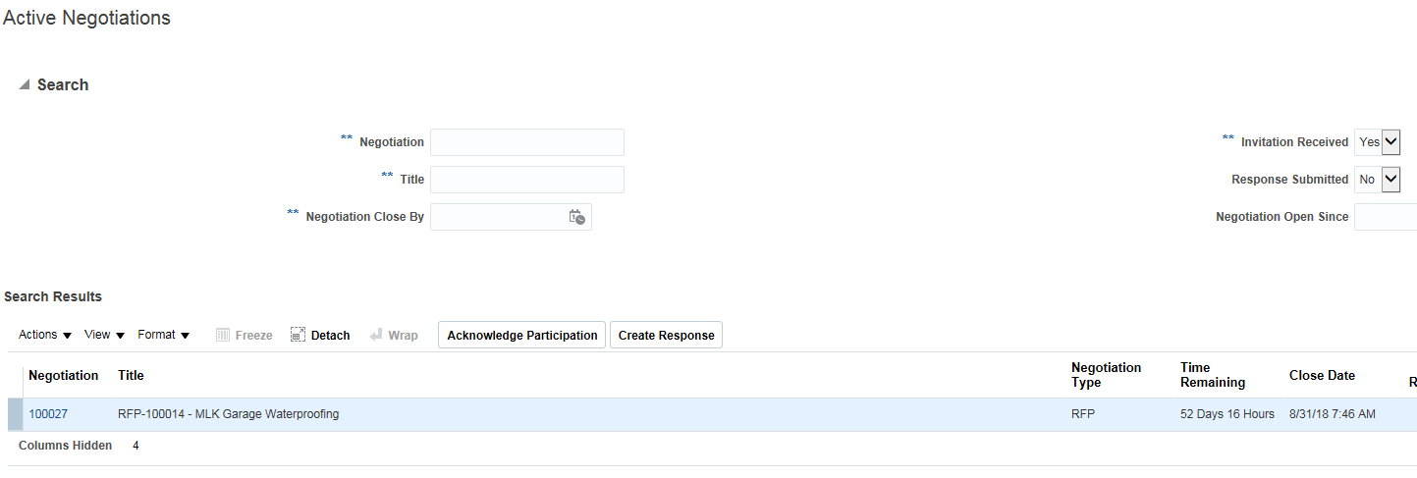

  - On the Overview page, do the following:
  - Enter your reference number in the Reference Number box
  - Enter a note to the buyer in the Note to Buyer box
  - Upload any attachments by clicking the + icon next to Attachments
  - Review and update any variables
  - Review and update any deliverables
  - Click the Next button

  - On the Requirements page, answer all the questions and click the Next button.
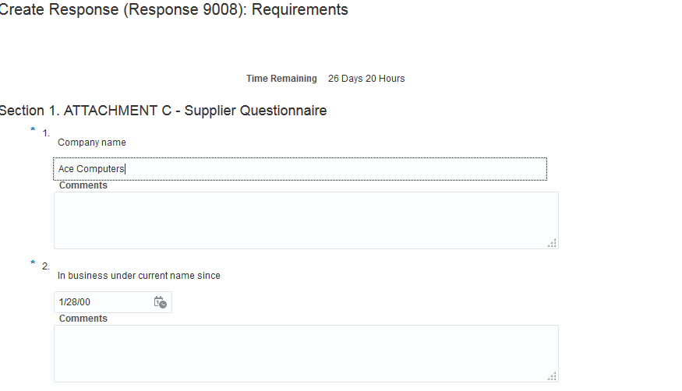

  - On the Lines page, enter the Response Price for all the line items. Verify the total amount at the bottom of the page for the accuracy of the prices entered, and then click the Next button.
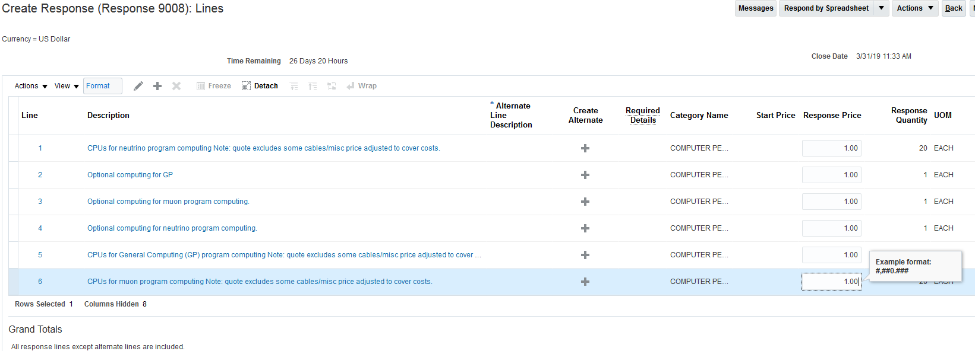

  - On the Review Response page, review your response details. To validate that you have entered the required information, click Actions > Validate.

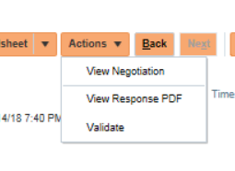

  - Click the Save button. Then click the Submit button.
  - You will see a confirmation message. Click OK.

How to send a message to your solicitation buyer

This section provides instructions on how to send a message to your solicitation buyer.

  - On the Supplier Portal login screen, enter your username and password. Then click the Sign In button.

  - Search for the solicitation number.

  - Under Search Results, click the solicitation link.
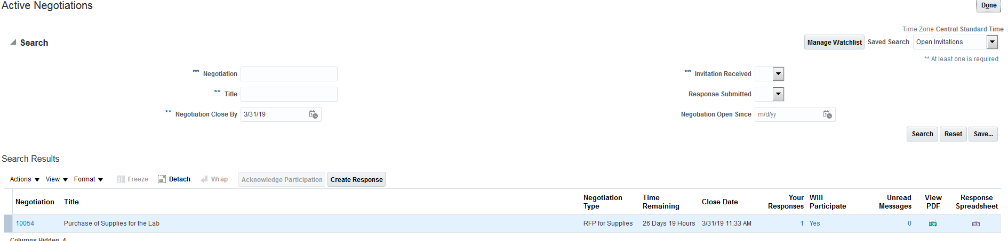

  - Click the Messages button.
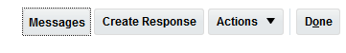
  - Click the + icon to create a new message.
  - Enter a subject and type your message. You can also add attachments if needed. When you are done, click the Send button.
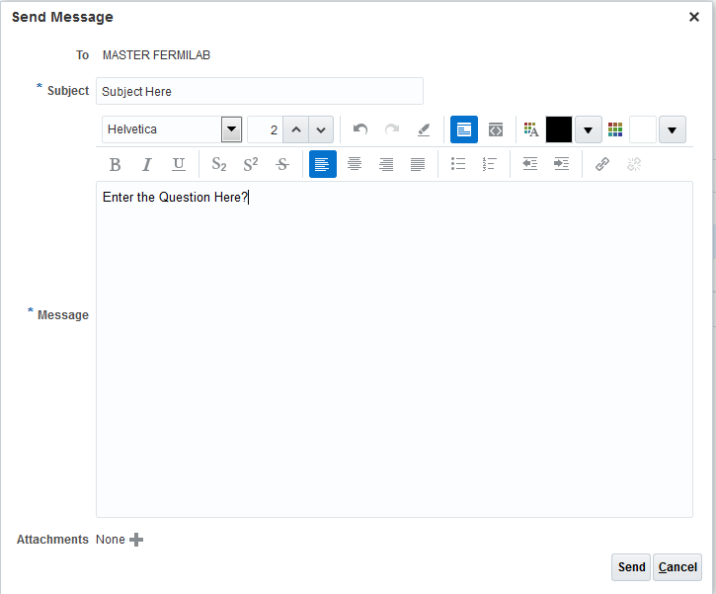

  - Click the Done button.

How to respond to a message from a solicitation buyer

If solicitation buyers want to ask you a question, they will send you a message via the Supplier Portal. This paragraph provides instructions on how to respond to such messages in the Supplier Portal.

  - On the Supplier Portal login screen, enter your username and password. Then click the Sign In button.

  - Click the bell-shaped Notification icon in the top-right corner.
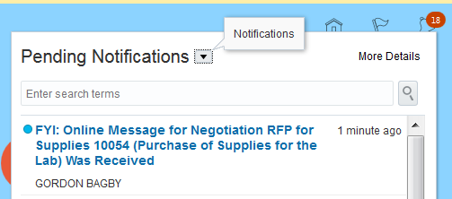

  - Click the link in your notification list to open the message.

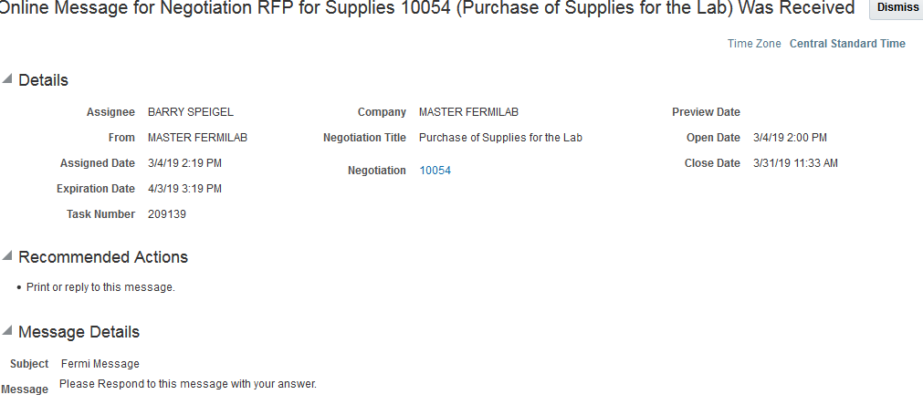

  - Click the View Message Details link.
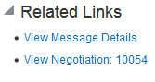

  - Click the Reply button to reply to this message.
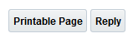

  - The original message from the buyer will be displayed. Add your reply to the message. You can also add attachments as needed. When you are ready to send the reply, click the Send button.
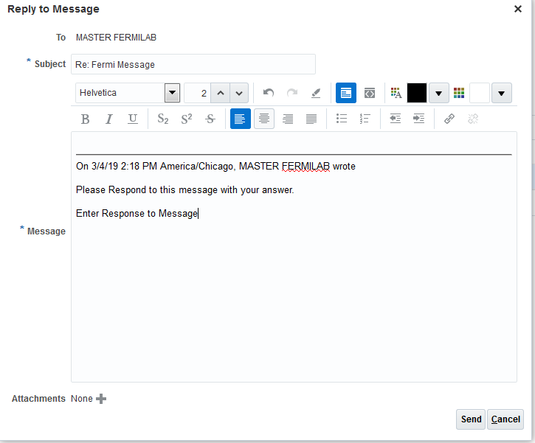

  - Your reply status will be shown on the Online Messages page. Click the Done button.
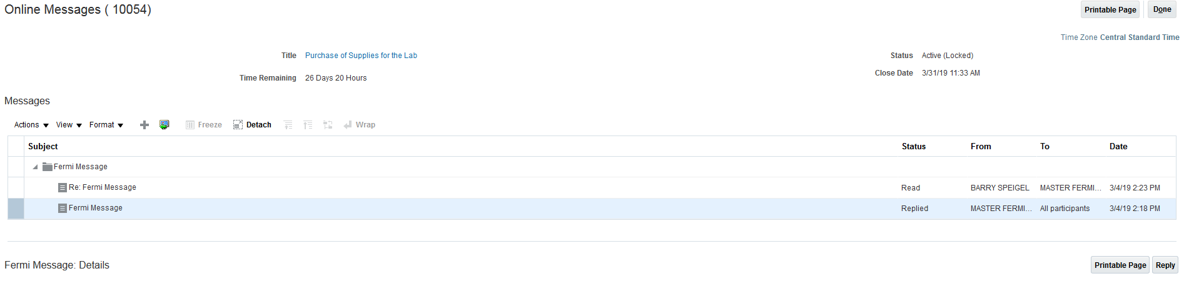

How to revise a solicitation response

This paragraph provides instructions on how to revise a solicitation response.
  - On the Supplier Portal login screen, enter your username and password. Then click the Sign In button.

  - In the Tasks box on the left, click the View Active Solicitations link.

  - Select the solicitation and click the View Response History link.
  - Select the response you want to revise and click the Revise button. All the details from the original response will be copied over.
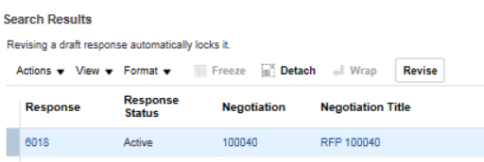

  - Update your response details. When you are done, click the Save button and then click the Submit button.

How to respond to a solicitation amendment

This document provides instructions on how to respond to a solicitation amendment in the Supplier Portal. You will receive an email notification if the amendment to the active solicitation has been issued.
  - On the Supplier Portal login screen, enter your username and password. Then click the Sign In button.

  - Click the Home button in the top-right corner. Then click the Worklist icon.

  - In your worklist, click the solicitation amendment link.
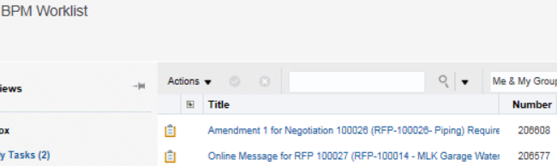

  - Review the amendment details.
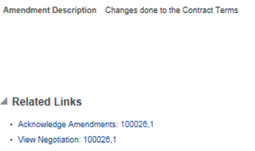
  - To acknowledge the amendment, check the box I have reviewed the changes and I acknowledge amendment x for negotiation xxxxxx.
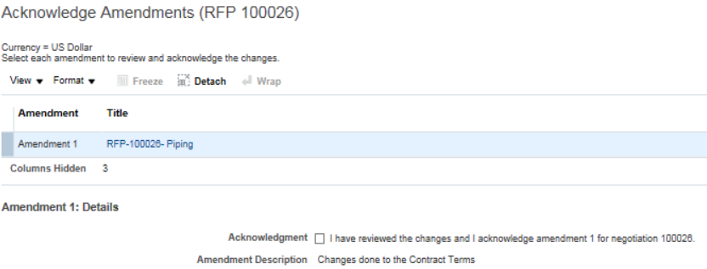
  - Click the Submit button. You then need to re-respond to the solicitation by performing the next steps.
  - If you want to create a new response to the solicitation at this moment, please select Yes button to continue. Otherwise click No button.
- Select the solicitation and click Create Response. If you would like to use your previous response as a base of the new response, checkmark Copy from an existing response checkbox and then select the response version you want to use.
- Then select the existing response or draft and click Create Response.

  - On the Overview page, review and update any response details as needed. Then click the Next button.
  - On the Requirements page, review and update any data as needed and click the Next button.
  - On the Lines page, enter the Response Price for all lines. Please note that the original prices will not be carried over and you will need to re-enter them or enter new prices. When you are done, click the Next button.
  - On the Review Response page, review your response details. To validate that you have entered the required information, click Actions > Validate.

  - When you are ready to submit this response, click the Save button and then click the Submit button.
  - You will see a confirmation message. Click OK.

How to withdraw from a solicitation

This section provides instructions on how to withdraw from a solicitation.
  - On the Supplier Portal login screen, enter your username and password. Then click the Sign In button.
  - In the Tasks box on the left, click the Manage Responses link.

  - Select the response of the solicitation from which you want to withdraw and then click the Revise button.
  - Enter a note in the Note to Buyer box to indicate that you want to withdraw from this solicitation. Then click the Submit button.
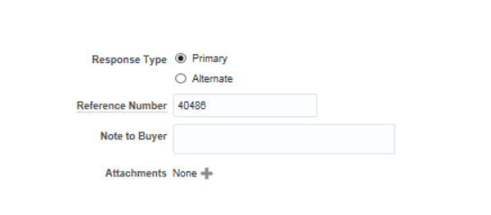
  - You will see a confirmation message. Click OK.

