Dear Suppliers,

We are starting to reset your Supplier Portal passwords this evening. In the next few days you will be receiving the Reset password email. This process will take a few days to complete for all the accounts, but some will see these emails as early as this evening. We would like to make sure this is not a challenging or frustrating task therefore we would like to ask you to closely follow the instructions below.

If you have any questions, please feel free to contact us at [suppliers@fnal.gov](mailto:suppliers@fnal.gov).



**Supplier Portal password reset instructions**

1. Click supplier password link received in the email. Following login page will be loaded.

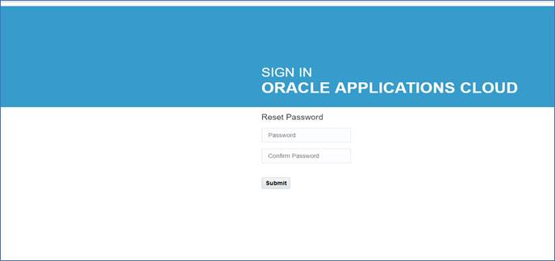

1. Enter your new password, confirm and then click **Submit** button.
2. You will be forwarded to the following single sign-on **but do not try to login through this page.**

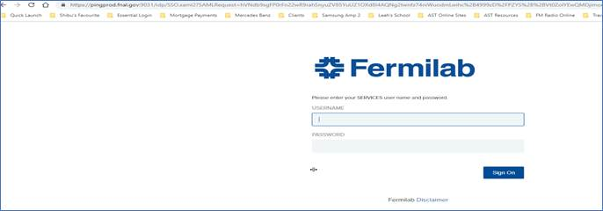

1. Close this page and use the “Supplier Portal Access -  Existing Supplier” button available at   <https://procurement.fnal.gov/supplier-portal> or bookmark the following link:

<https://eigf.fa.us8.oraclecloud.com/fscmUI/faces/FndOverview?fndGlobalItemNodeId=itemNode_supplier_portal_supplier_portal>

1. Proper login page

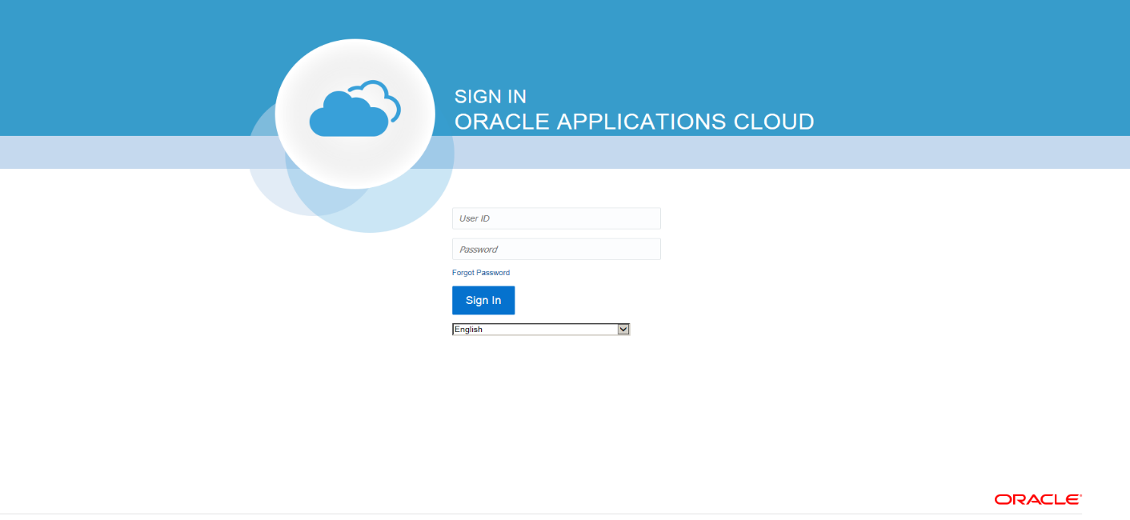

If you have any questions, please feel free to contact us at [suppliers@fnal.gov](mailto:suppliers@fnal.gov).

Regards,

Fermilab Procurement Department  
<http://procurement.fnal.gov>  
[suppliers@fnal.gov](mailto:suppliers@fnal.gov)  
(630) 840-3521