Dear Supplier,

An account has been created for you in our Supplier Portal. You will receive first a notification that your account has been created in the portal. The next email sent to you will contain a link to reset your password. If you can not see these emails in your inbox please check your Spam/Junk/Clutter folder.

We would like to make sure this is not a challenging or frustrating task therefore we would like to ask you to closely follow the instructions below.



**Supplier Portal password reset instructions**

1. Click supplier password link received in the email. Following login page will be loaded.

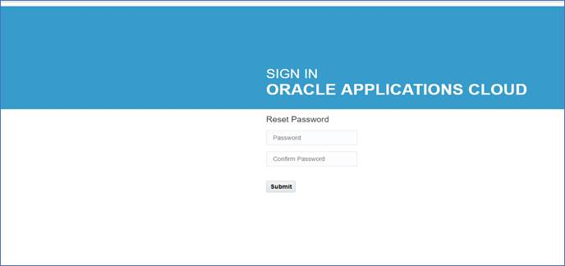

1. Enter your new password, confirm and then click **Submit** button.
2. You will be redirected to the login page. Click Sign In button.

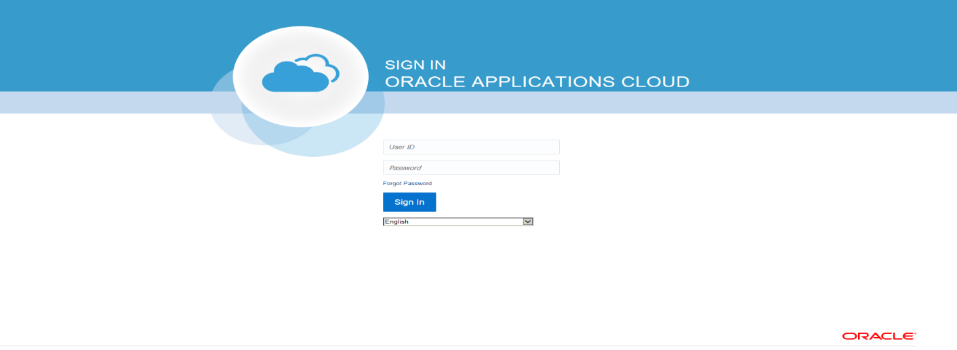

1. On the login page enter your login id (email address) and new password and click Sign In button.

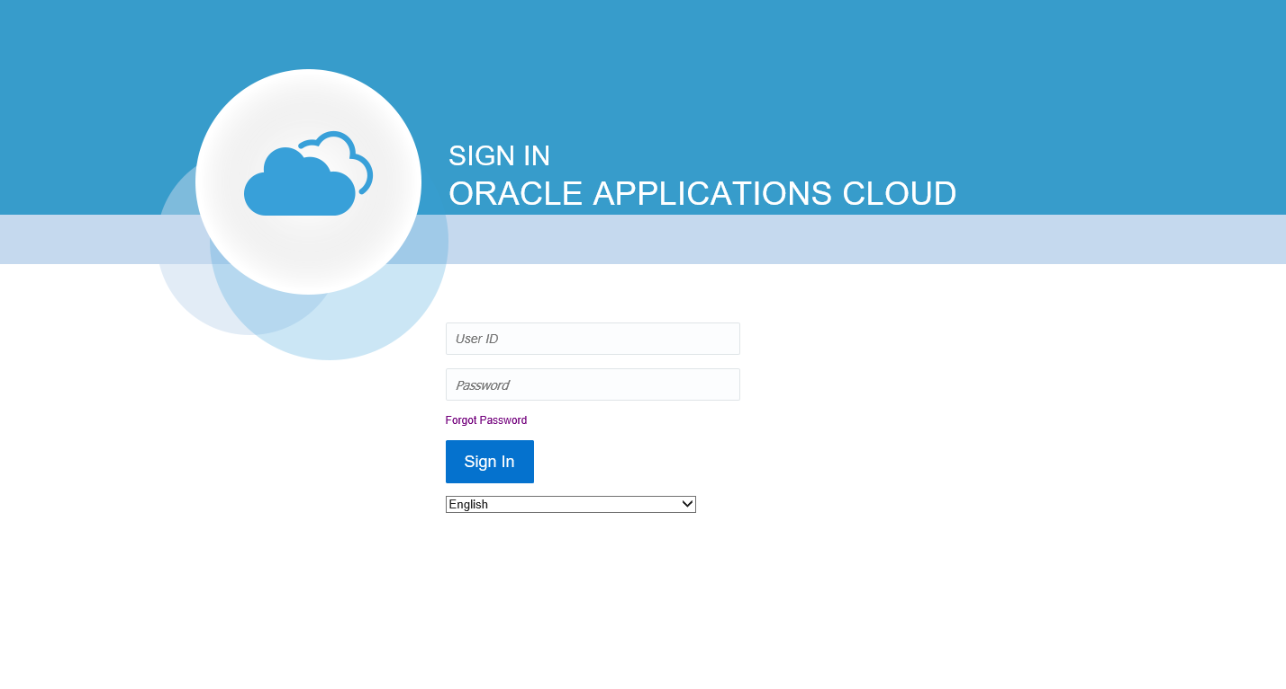

Note. To access Supplier Portal going forward, you can bookmark the following link

<https://eigf.fa.us8.oraclecloud.com/fscmUI/faces/FndOverview?fndGlobalItemNodeId=itemNode_supplier_portal_supplier_portal>

or use “Supplier Portal Access -  Existing Supplier” button available at   <https://procurement.fnal.gov/supplier-portal>

If you have any questions, please feel free to contact us at [suppliers@fnal.gov](mailto:suppliers@fnal.gov).

Regards,

Fermilab Procurement Department  
<http://procurement.fnal.gov>  
[suppliers@fnal.gov](mailto:suppliers@fnal.gov)  
(630) 840-3521