1. Please use Forgot Password option available on the login screen and set your new password

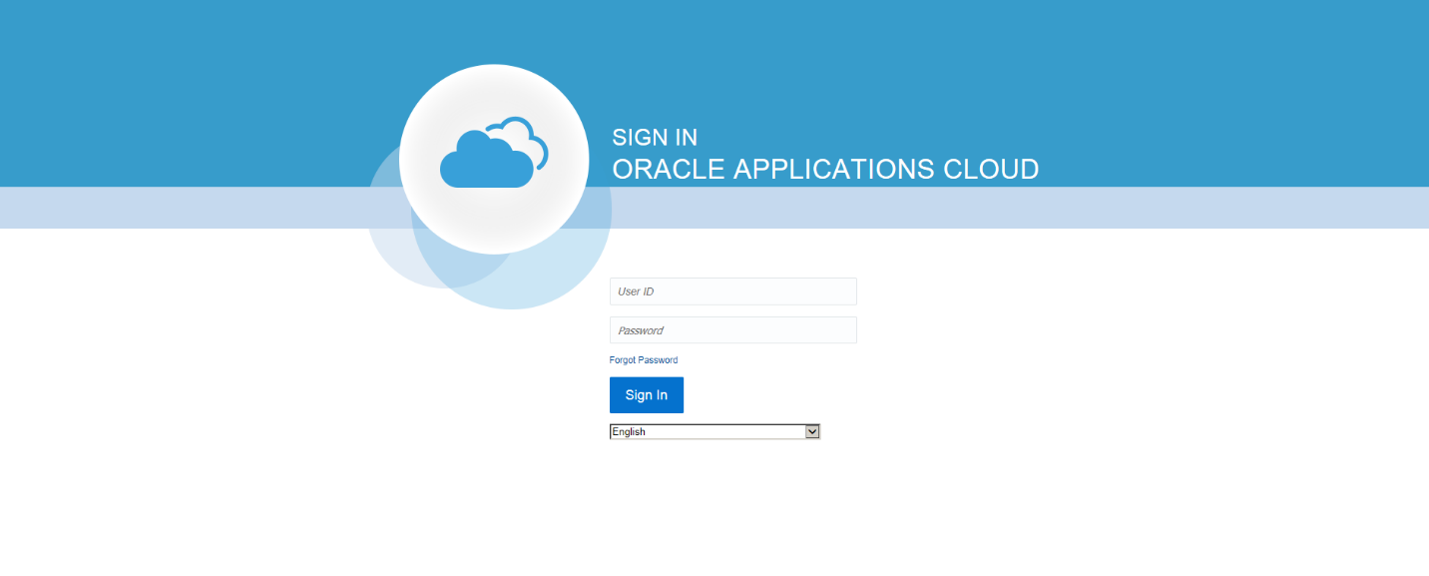

1. To get there you can use the link on our website (Supplier Portal Access – existing suppliers) or use the one that I have pasted below:

[https://eigf.fa.us8.oraclecloud.com/fscmUI/faces/FndOverview?fndGlobalItemNodeId=itemNode_supplier_portal_supplier_portal](https://urldefense.proofpoint.com/v2/url?u=https-3A__eigf.fa.us8.oraclecloud.com_fscmUI_faces_FndOverview-3FfndGlobalItemNodeId-3DitemNode-5Fsupplier-5Fportal-5Fsupplier-5Fportal&d=DwMFAw&c=gRgGjJ3BkIsb5y6s49QqsA&r=t9NCH6N6RWBTfdE63Hl2Fbajt7KSFaEsurftaXeZf5A&m=w69rANJgqKtbc73iDzqk3M82cFF-3U84A0aiC7AP_zc&s=c6azpwSCE6ldAFYcn6l5fqGJ5BzrteYtqxE3JfqftI4&e=)

1. Proper login page

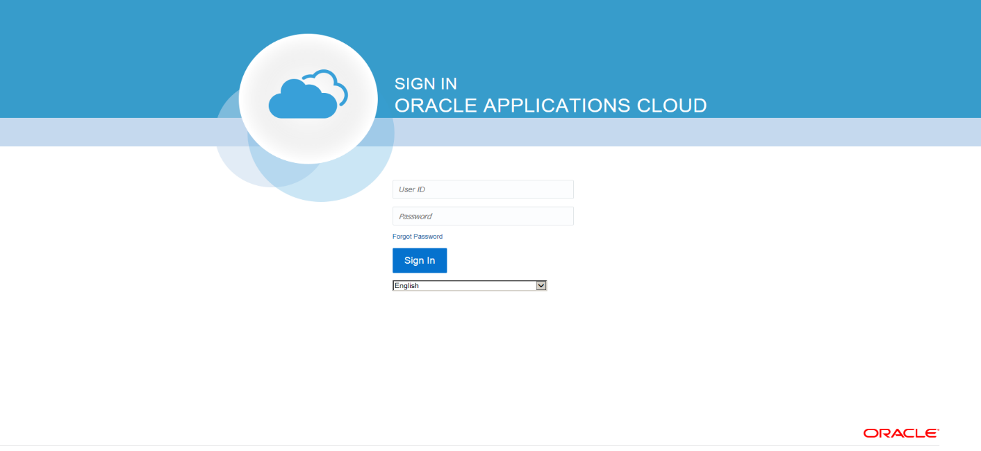

1. If you are forwarded to the following single sign-on **but do not try to login through this page.**

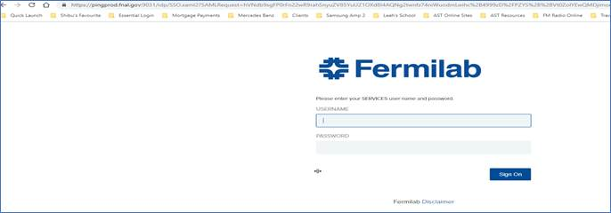

1. Close this page and use the “Supplier Portal Access -  Existing Supplier” button available at   <https://procurement.fnal.gov/supplier-portal> or bookmark the following link:

<https://eigf.fa.us8.oraclecloud.com/fscmUI/faces/FndOverview?fndGlobalItemNodeId=itemNode_supplier_portal_supplier_portal>